|  |  |
| --- | --- |
| When 12-13 September, and  15-17 September 2024 | |
| Hours of work Between the hours of 7pm and 6am | |
| Where Aldinga Beach Road and Main South Road | |
| More information Visit  [www.fcalliance.com.au](http://www.fcalliance.com.au)  Email [info@fcalliance.com.au](mailto:info@fcalliance.com.au)  Call 1300 896 826 (24hrs) | |
|  | |
|  | Better connections  to the iconic Fleurieu Peninsula. |
|  | Keeping you moving with a smoother, safer ride. |
|  | Supporting over 400 jobs each year |

**We’re doubling the capacity of Main South Road from Aldinga to Sellicks Beach to improve safety and make your journey more reliable.**

The $810 million Fleurieu Connections project is jointly funded by the Australian and South Australian governments.

## What’s happening

Night works will be undertaken on Aldinga Beach Road **on Thursday 12 September, Friday 13 September, Sunday 15 September and Monday 16 September 2024** before traffic is moved onto the new Aldinga Beach Road alignment from **Tuesday 17 September 2024.**

## How this affects you

To keep everyone safe, speed and lane restrictions will remain in place while throughout the project area. Works will include installation of new and removal of old safety barriers as well as asphalt works and line marking on the new surface.

Some noise disturbance can be expected, but we’ll try to keep these disturbances to a minimum. Please follow traffic management directions while work is in progress. In addition, we will contact you if the work directly impacts your property and local access will be maintained. Adverse weather may impact our works, but we’ll keep you updated via our website.

### Road realignment on Aldinga Beach Road

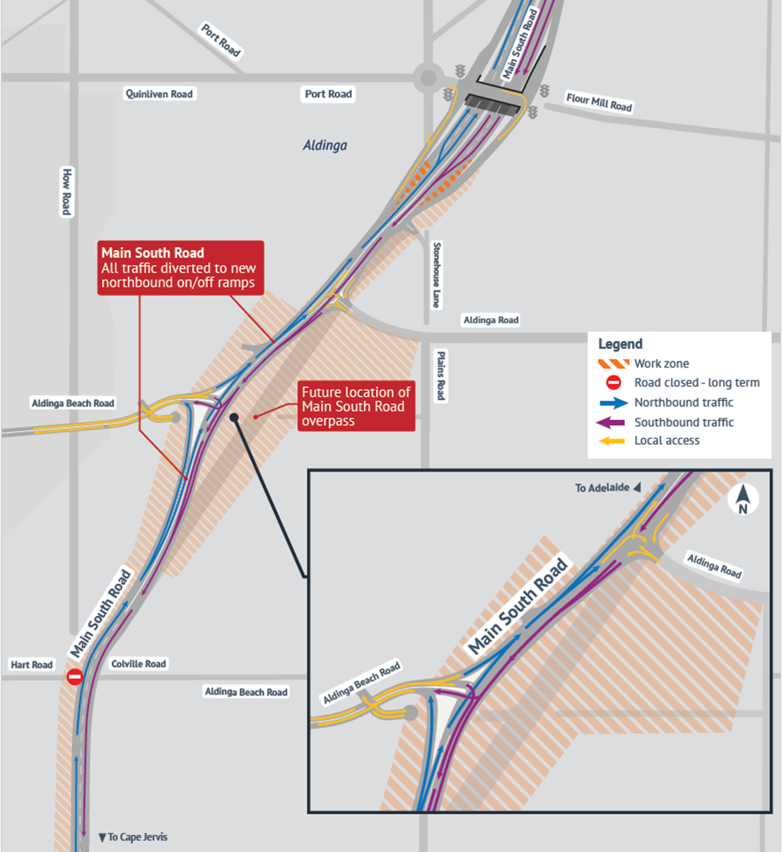

From Tuesday 17 September 2024, traffic on Aldinga Beach Road will be moved onto a new alignment, which will become part of the new Aldinga Interchange approach. Access to properties will be maintained, with new access arrangements in place from this date. Our team will contact residents in advance to discuss the changes.